How to launch Dataprep in GCP & overview of cloud Dataprep console

This document shows “How to launch cloud dataprep and cloud dataprep console overview”.

Go to Big Data section

* Select DataPrep
* Go to Dataprep
  + It will ask “share information with Trifacta”
    - click on continue.

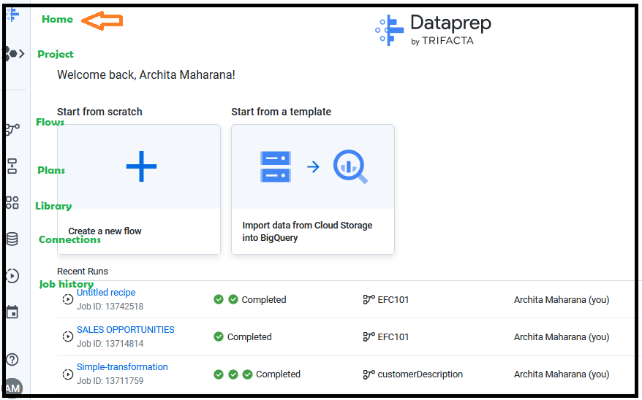

Home: redirects to home page of dataprep.

Projects: it shows which project we are in. we can switch between multiple projects.

Flow: we can import dataset to flow by exporting data from other projects.

Library: we can see here all working datasets. We can import the data also.

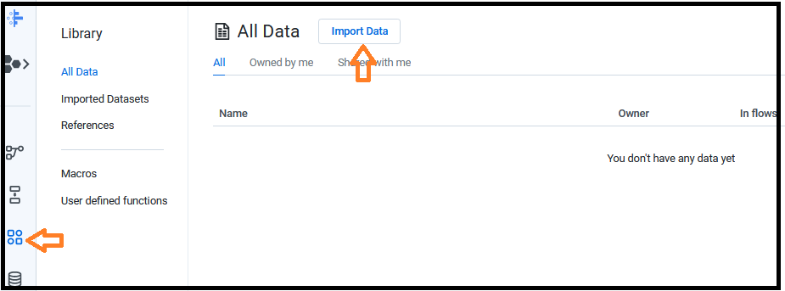

Job: we can check all details related to jobs like executed, failed, running and cancelled jobs etc.

end